# Khan Academy

## What is Khan Academy (YouTube Channel)?

**# Source**: **Chatgpt (GPT-5-Standard) at [8/27/2025]**

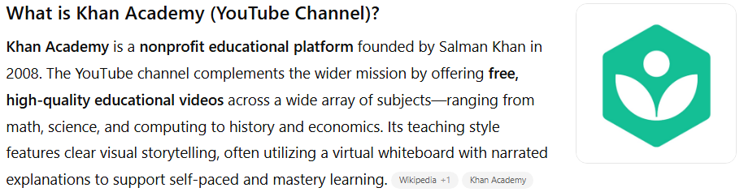

**Khan Academy** is a **nonprofit educational platform** founded by Salman Khan in 2008. The YouTube channel complements the wider mission by offering **free, high-quality educational videos** across a wide array of subjects—ranging from math, science, and computing to history and economics. Its teaching style features clear visual storytelling, often utilizing a virtual whiteboard with narrated explanations to support self-paced and mastery learning.([Wikipedia](https://en.wikipedia.org/wiki/Khan_Academy?utm_source=chatgpt.com), [Khan Academy](https://support.khanacademy.org/hc/en-us/articles/202483180-What-is-the-history-of-Khan-Academy?utm_source=chatgpt.com))

The channel supports flipped-classroom models, offers SAT and LSAT preparation, and serves learners worldwide through rich video tutorials and practice exercises.([Wikipedia](https://en.wikipedia.org/wiki/Khan_Academy?utm_source=chatgpt.com), [WIRED](https://www.wired.com/2011/05/kahns-youtube-revolution?utm_source=chatgpt.com), [Khan Academy](https://support.khanacademy.org/hc/en-us/articles/202483180-What-is-the-history-of-Khan-Academy?utm_source=chatgpt.com))

## Key Highlights

**# Source**: **Chatgpt (GPT-5-Standard) at [8/27/2025]**

* **Platform:** YouTube
* **Language:** Primarily English (with subtitles in many languages)
* **Content Focus:** Academic subjects and test prep through video tutorials
* **Subscribers:** ~9.03 million (as of August 2025)([vidIQ](https://vidiq.com/youtube-stats/channel/UC4a-Gbdw7vOaccHmFo40b9g/?utm_source=chatgpt.com), [Social Blade](https://socialblade.com/youtube/handle/khanacademy?utm_source=chatgpt.com), [Wikipedia](https://en.wikipedia.org/wiki/Khan_Academy?utm_source=chatgpt.com))
* **Total Views:** ~2.17 billion([vidIQ](https://vidiq.com/youtube-stats/channel/UC4a-Gbdw7vOaccHmFo40b9g/?utm_source=chatgpt.com), [Social Blade](https://socialblade.com/youtube/handle/khanacademy?utm_source=chatgpt.com))

## Summary Table

**# Source**: **Chatgpt (GPT-5-Standard) at [8/27/2025]**

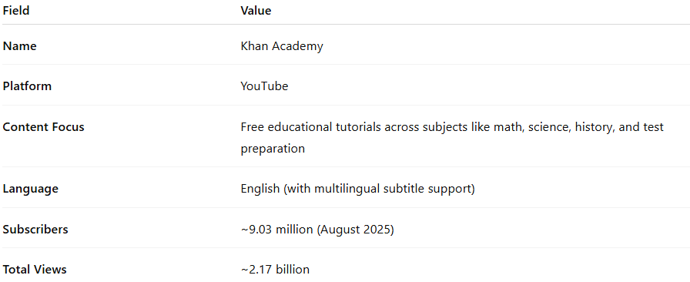

| **Field** | **Value** |
| --- | --- |
| **Name** | Khan Academy |
| **Platform** | YouTube |
| **Content Focus** | Free educational tutorials across subjects like math, science, history, and test preparation |
| **Language** | English (with multilingual subtitle support) |
| **Subscribers** | ~9.03 million (August 2025) |
| **Total Views** | ~2.17 billion |